**TASK 3**

**CREATE AND OPTIMIZE AI PROMPTS FOR CONTENT GENERATION**

**Content Type Chosen:** Product Description  
**Theme:** Skincare  
**Product Name:** Vaseline® Blue Seal Original Petroleum Jelly

**Structured Prompt:**

Write a product description for a skincare product named Vaseline® Blue Seal Original Petroleum Jelly.

The product is made with triple-purified Petrolatum and is known for creating a gentle, moisturizing protective barrier. It is hypoallergenic, non-comedogenic, and suitable for all skin types.

The description should:

- Attract skincare-loving customers

- Explain the benefits clearly

- Highlight what makes the product special

- Sound elegant, engaging, and persuasive

- Encourage users to buy

Keep it under 150 words, and use a soft, confident tone.

**OR**

Write an engaging and elegant product description for Vaseline® Blue Seal Original Petroleum Jelly, a skincare essential made with triple-purified petrolatum. Highlight its key benefits like creating a protective skin barrier, deep hydration, and being hypoallergenic and non-comedogenic. Make the tone attractive for beauty-conscious customers, focus on skincare benefits and key ingredients, and encourage purchase through persuasive, aesthetic wording.

**AI-Generated Output:**

Use the above prompt in an AI tool-

* claude.ai

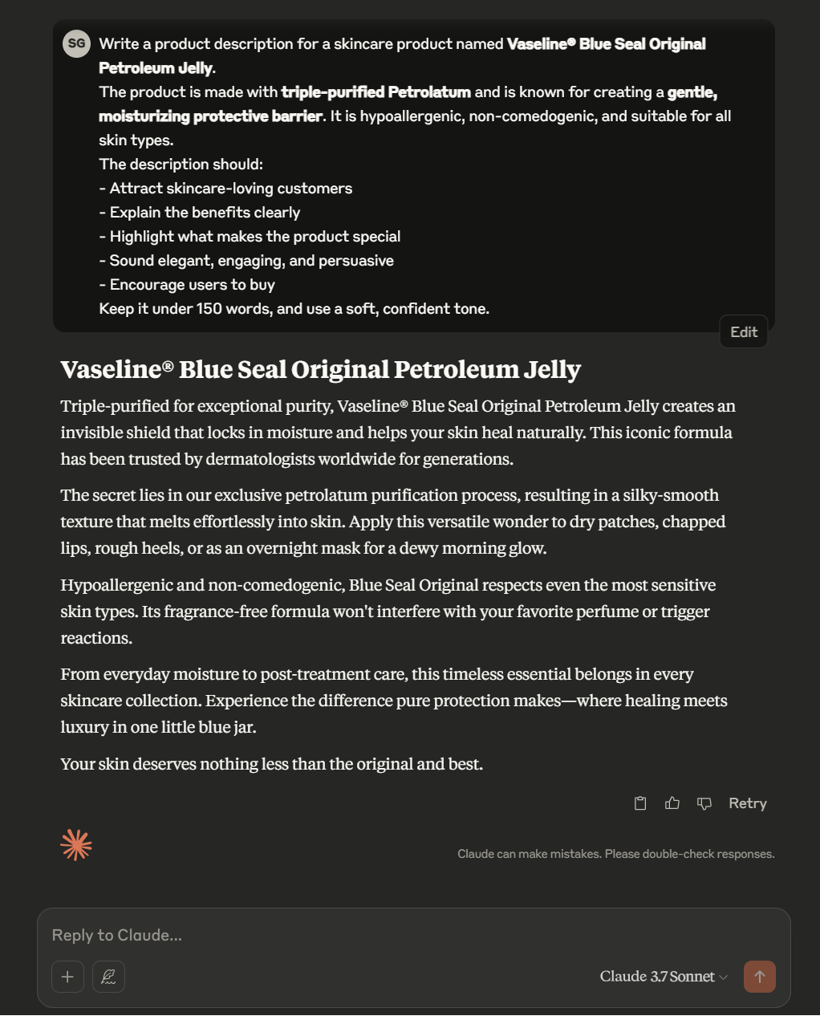

* blackbox.ai



* gemini.google.com

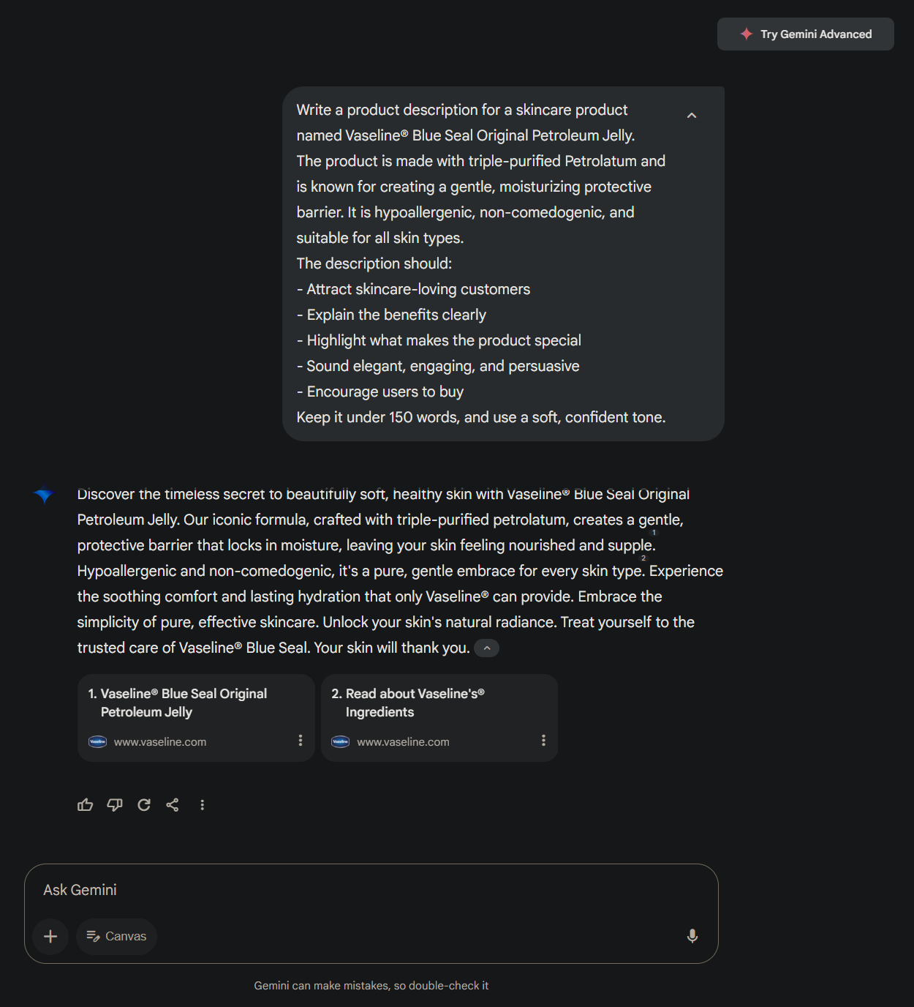

* perplexity.ai

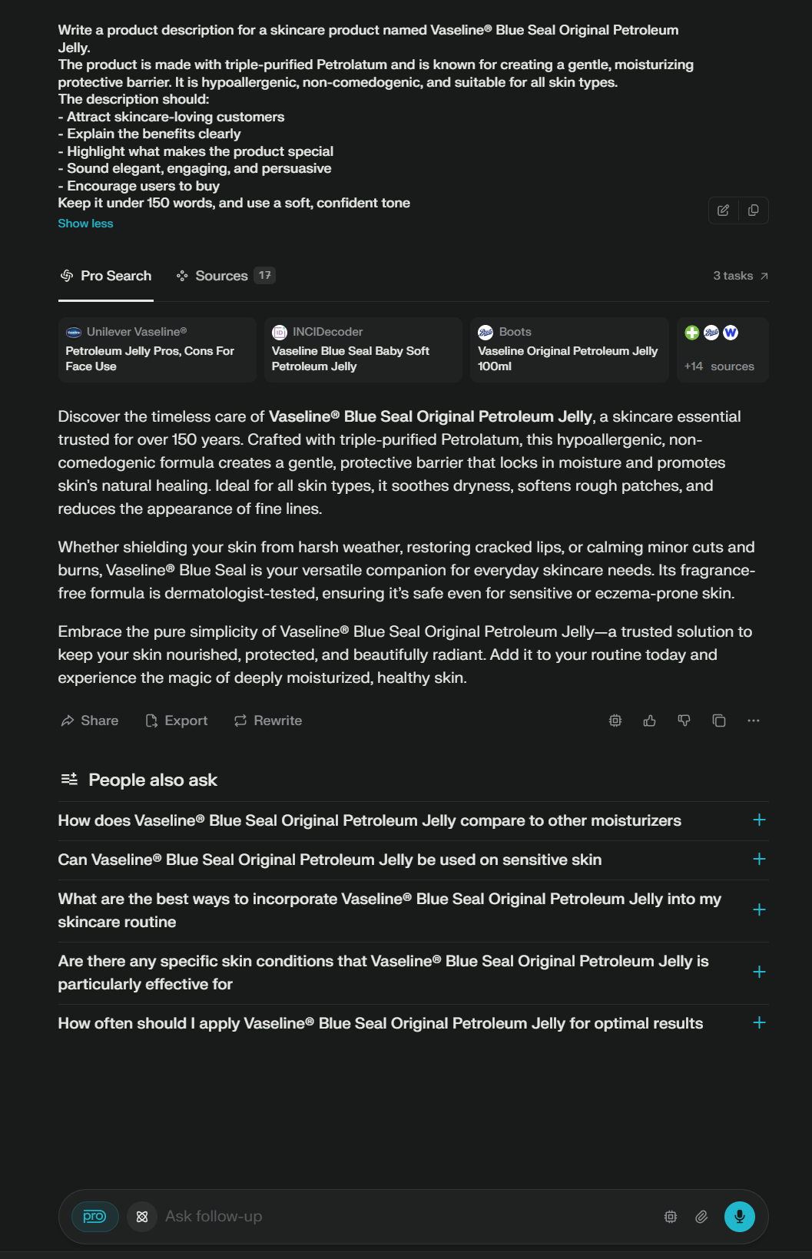

**Reflection / What I Learned:**

This task helped me deeply understand the importance of **clear, goal-oriented prompt writing**. Crafting a structured prompt that could guide the AI to generate a product description with the right tone, audience focus, and brand messaging was a learning experience. I realized that effective prompt engineering is not just about asking a question—it’s about providing context, setting the tone, and defining specific goals for the output.

While working on the Vaseline® product description, I learned how to:

* Emphasize key ingredients and benefits in a way that feels natural and persuasive,
* Tailor content for a skincare-conscious audience using soft, elegant language,
* Balance informative and emotional appeal in AI-generated writing.

Additionally, experimenting with different phrasings showed how the AI's response can vary in tone, depth, and structure. This gave me insight into how **prompt precision** leads to **more accurate, brand-aligned results**, which is essential for real-world applications like marketing, product launches, and digital content creation.

Overall, this task has boosted my confidence in using AI tools thoughtfully and strategically for creative content generation.

**Thankyou!**